NAME:PAREENITA A.SHIRSATH PRN:221101062 ROLL.NO:57 T.E.A.I.&.D.S.

**SBL-CC EXPERIMENT NO : 5**

STEP 1 : IN THE AWS MANAGEMENT CONSOLE,SEARCH FOR “RDS” USING THE SEARCH BAR AND SELECT THE RDS RESULT UNDER SERVICES.

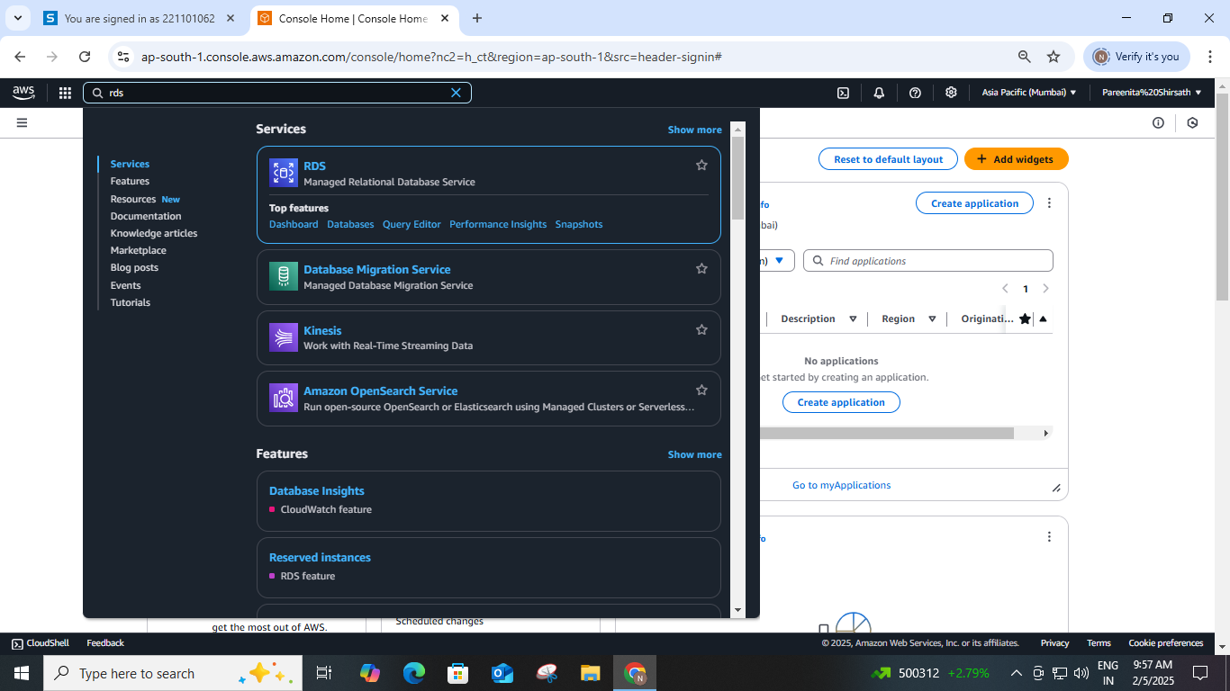

STEP 2 : CLICK ON “CREATE DATABASE” BUTTON .YOU WILL BE PROMPTED TO CONFIGURE YOUR DATABASE.

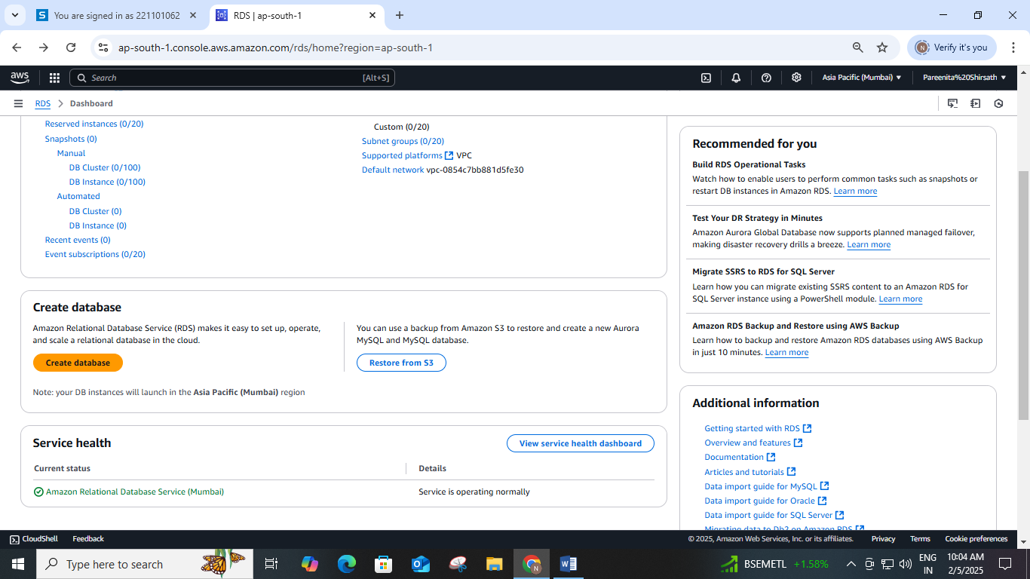

STEP 3 : CHOOSE DB CREATION METHOD AS “STANDARD CREATE” AND SELECT BELOW”MySQL”.

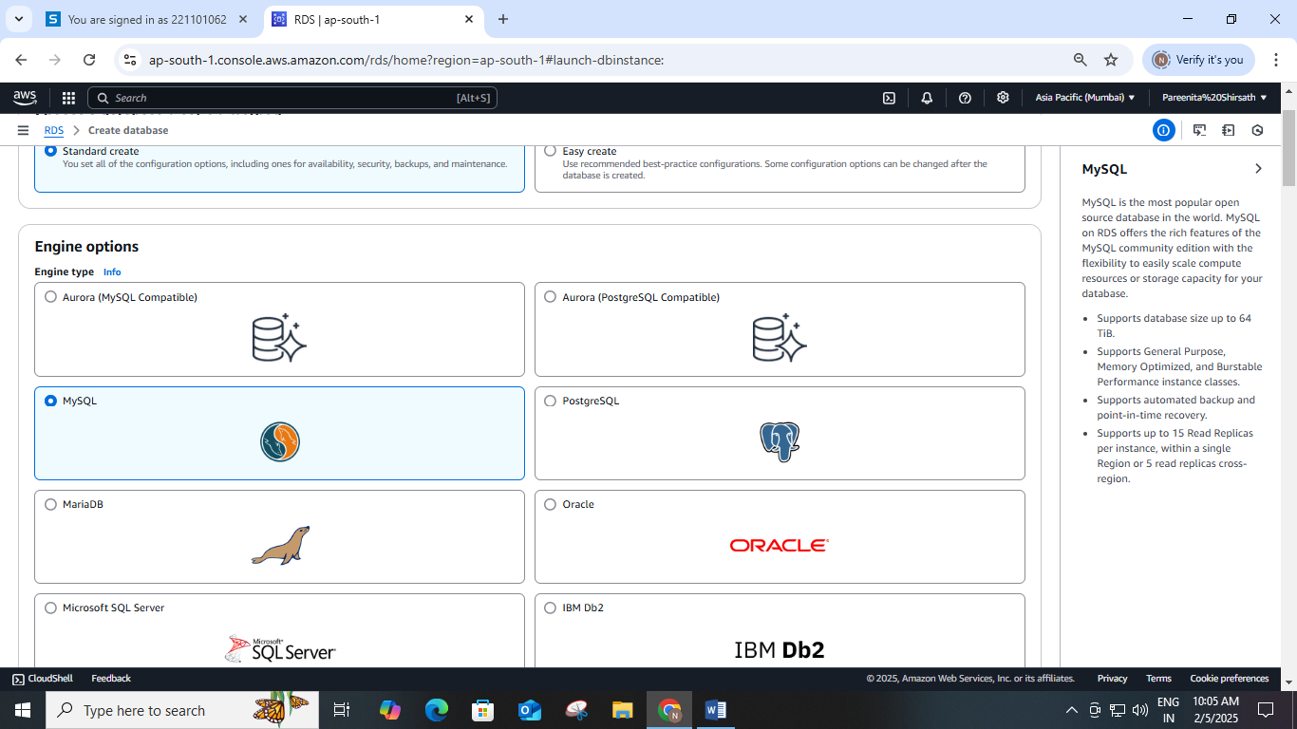

STEP 4 : CHOOSE DB INSTANCE SIZE: IN THE “TEMPLATES” SECTION, CHOOSE “FREE TIER”. THIS WILL AUTOMATICALLY SELECT THE “DB.T2.MICRO” OR “DB.T3.MICRO” INSTANCE TYPE.

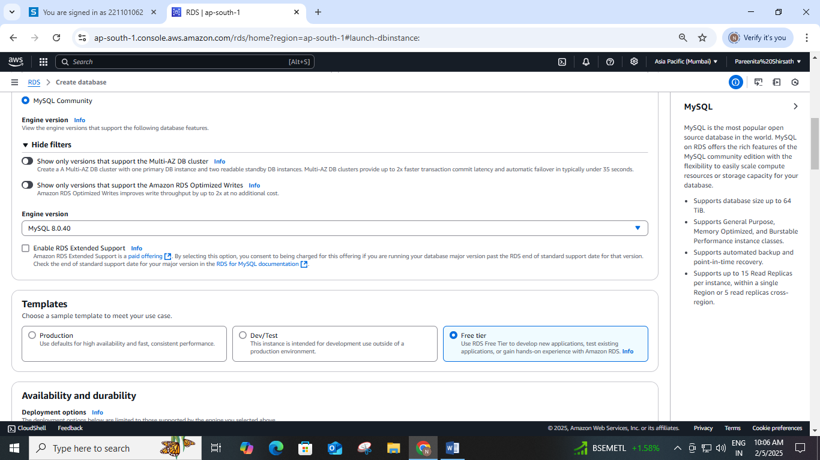

STEP 5 : CONFIGURE DB INSTANCE:

• DB INSTANCE IDENTIFIER: GIVE YOUR DB INSTANCE A UNIQUE NAME.

• MASTER USERNAME &AMP; PASSWORD: SET THE MASTER USERNAME AND PASSWORD FOR YOUR DATABASE.

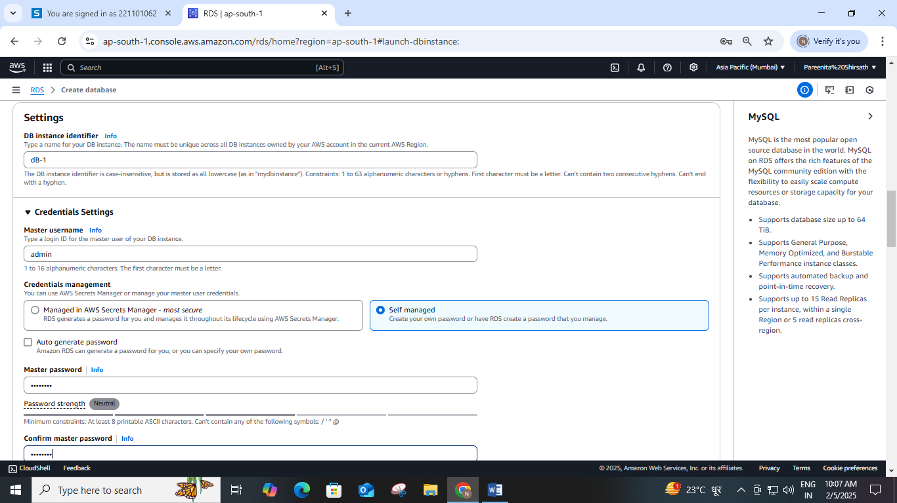

STEP 6 : SET THE ALLOCATED STORAGE TO 20 GIB ONLY.

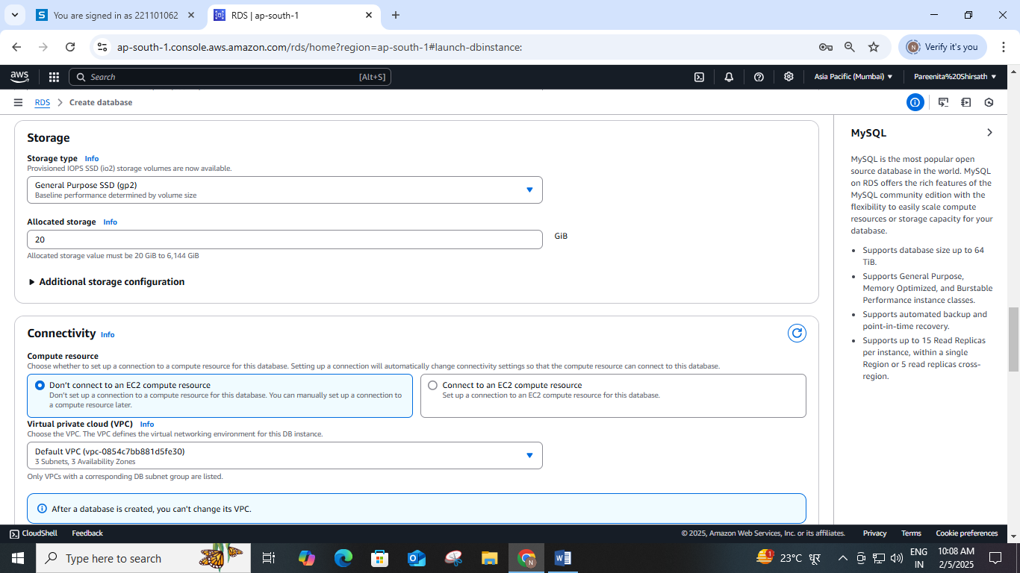

STEP 7 : UNDER CONNECTIVITY, ENABLE THE PUBLIC ACCESS OPTION.

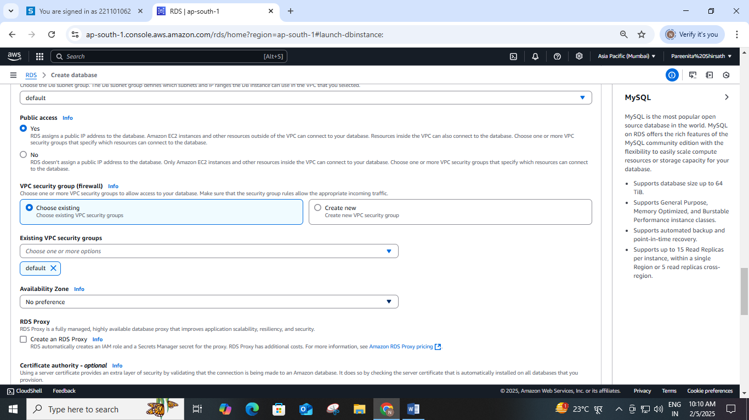

STEP 8 : UNDER CONNECTIVITY, CHOOSE THE CREATED SECURITY GROUP.

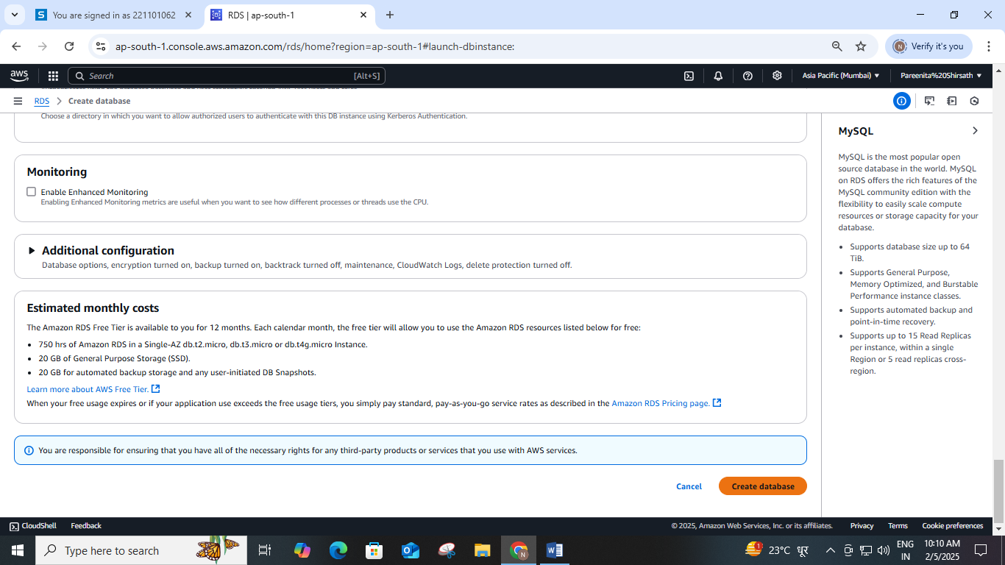

STEP 9 : AFTER CLICKING THE ‘CREATE DATABASE’ BUTTON, A CONFIRMATION WILL APPEAR TO LET YOU KNOW THAT THE PROCESS HAS STARTED AND THE DATABASE HAS BEEN CREATED.

